**Exhaustive Analysis of Indian Agriculture Sector using Power BI**

**What is Power BI?**

Power BI is a business intelligence (BI) tool by Microsoft that helps users analyze, visualize, and share data through interactive reports and dashboards.

**Key Features:**

Connects to various data sources (Excel, SQL, Web, APIs, etc.).

Uses Power Query for data cleaning and transformation.

Provides drag-and-drop visualization tools.

Supports real-time data updates and collaboration via Power BI Service

**Extract, Transform, and Load (ETL) in Power BI:**

ETL is a key process in Power BI used to handle data efficiently:

1. Extract € – Retrieving data from different sources (Excel, SQL, Web, APIs, etc.).
2. Transform (T) – Cleaning, filtering, and modifying data using Power Query to ensure it is structured properly.
3. Load (L) – Loading the transformed data into Power BI for visualization and reporting.

This process ensures data quality and prepares it for meaningful insights.

**STEP TO LOAD DATA INTO POWER BI :**

**Step 1: Open Power BI**

Launch Power BI Desktop on your computer.

If you don’t have it installed, download it from the Microsoft Power BI website.

In Power BI dashboard, Canva refers to the canvas or report canvas, which is the central area where you create and design visualizations, charts, tables, and other elements for your report.

It’s the workspace where you drag and drop fields from the Fields pane to build interactive reports and dashboards.

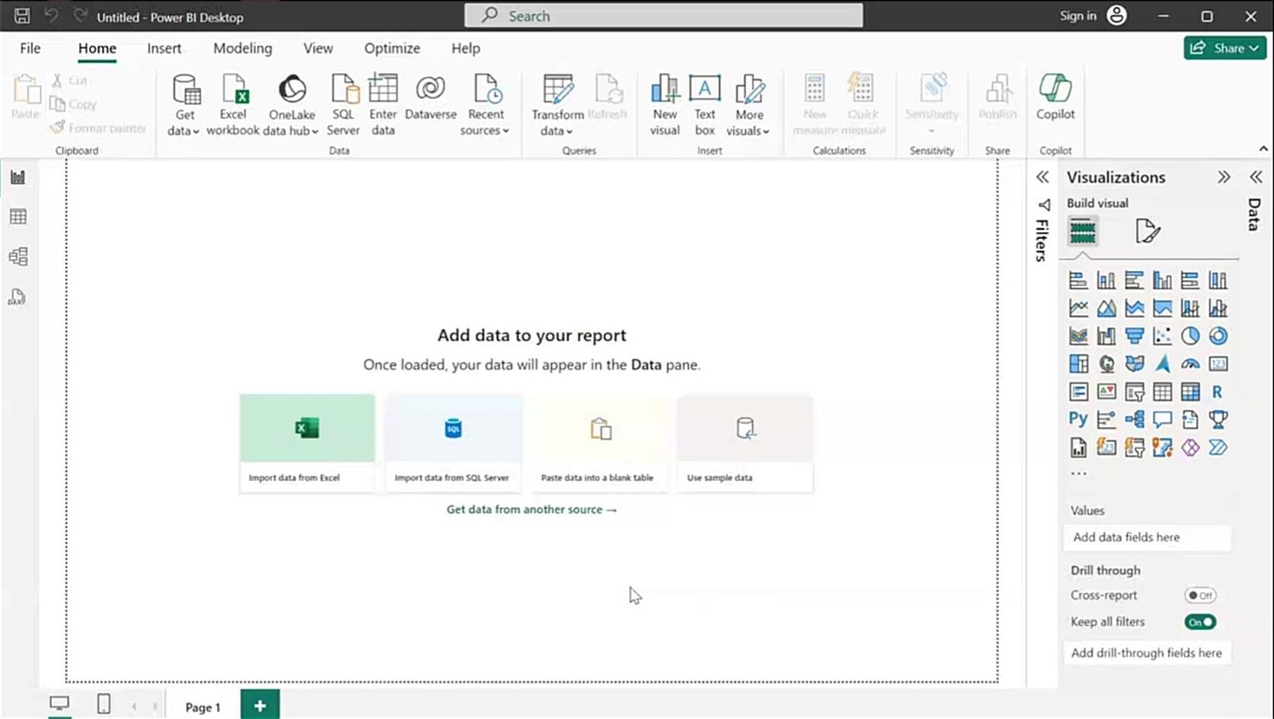

**Step 2: Import the required File**

Click on “Home” in the top menu.

Select “Get Data” → “Text/CSV”.

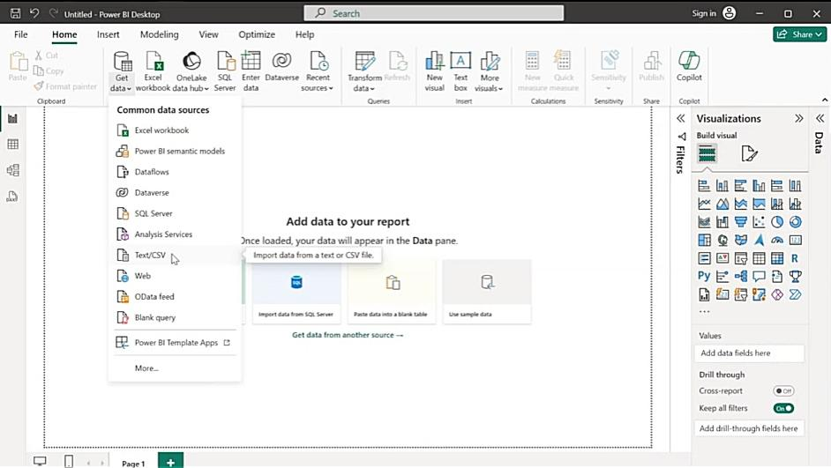

Browse to the location where your CSV file is stored.

Click “Open”.

**Step 3: Preview and Load the Data**

A preview window will appear displaying the contents of the CSV file.

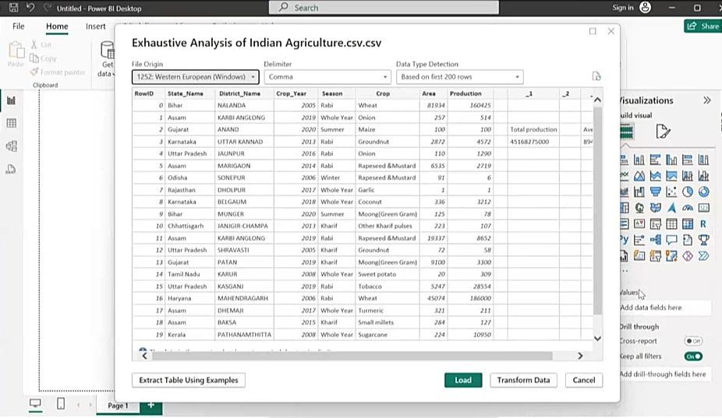

Check if Power BI correctly detects column headers and data types.

If the data looks fine, click “Load” to import it directly.

If you need to make transformations, click “Transform Data” in the Power BI dashboard to open Power Query Editor.

**Step 4: Transform Data (Optional)**

If you selected “Transform Data”, you can:

Rename columns by double-clicking the column header.

Change data types using the “Data Type” dropdown in the toolbar.

Remove or filter rows using right-click the row and select “Remove” or use the “Remove Rows” option in the toolbar.

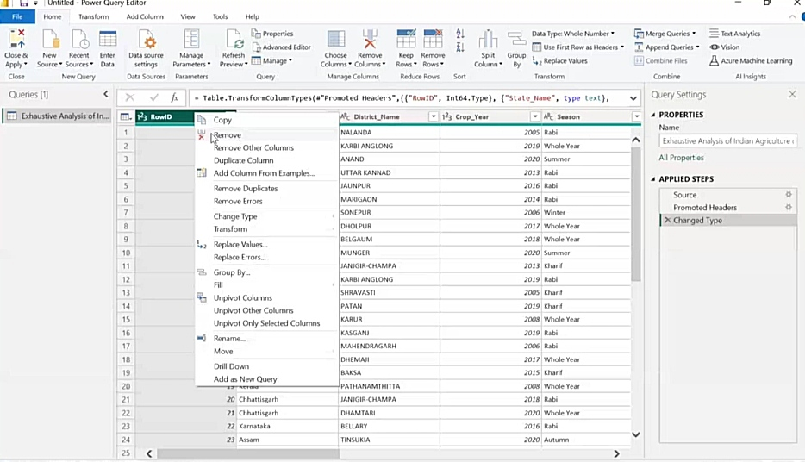

**To restore removed rows in Power Query Editor, click “Undo” (Ctrl + Z) or go to the “Applied Steps” pane and delete the “Removed Rows” step.**

Once done, click “Close & Apply” to save the changes and load the data into Power BI.

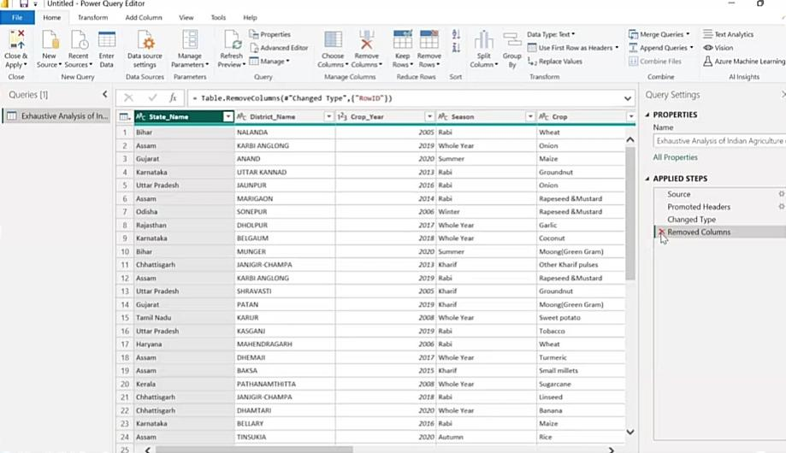

**Step 5: Create Visualizations**

Your data will now be available in the Fields pane. You can use Report View to create and design visualizations, charts, and dashboards.

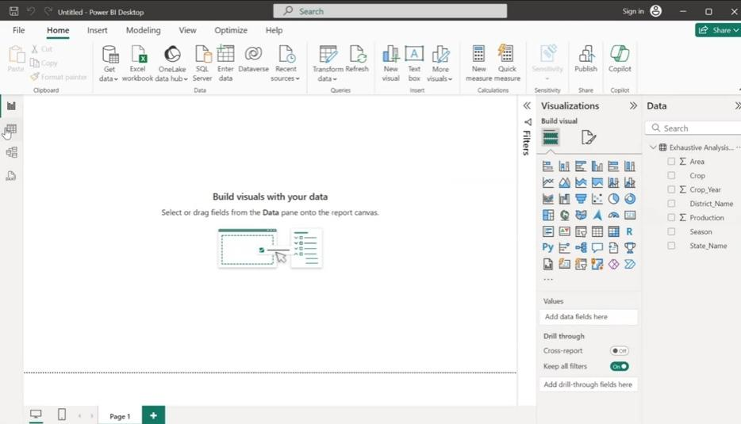

**Step 6: Save Your Work**

Click “File” → “Save As” and save your Power BI file (.pbix).

**Views in Power BI**

1. Report View – Used to create and design visualizations, charts, and interactive dashboards.
2. Table View (Data View) – Displays raw data in a table format, allowing you to inspect and verify data after loading.
3. Model View – Shows relationships between tables, helping you manage and define connections for better data modeling.